MBTA Transport Assistance
Nanda Kishore Bhat  Team Member  bhat.n@husky.neu.edu | Quazi Farhan  Team Member  farhan.q@husky.neu.edu | Serkan Okur  Team Member  okur.s@husky.neu.edu
Northeastern University, College of Computer & Information Science,
360 Huntington Avenue, Boston, Massachusetts 02115

ABSTRACT

Copyright is held by the authors.
Permission to make digital or hard copies of all or part of this work for personal or classroom use is granted.
To copy otherwise, or republish, to post on servers or to redistribute to lists, requires prior specific permission.
In this paper we present the final report for our MBTA Transport Assistance Project for Human & Computer Interaction Spring 2012 class at College of Computer and Information Science (CCIS) at Northeastern University.
Our project is a mobile application that concentrates on conventional Human & Computer Interaction (HCI) principles to make it usable by older adults. It runs on smart phones that use Android [1] v2.0.1 or higher operating systems.
The application is intended to show the real time arrival time information of MBTA transport vehicles in Boston area using the MBTA feed [2].
Due to time limitations; as of the date of this report, it is limited to Blue, Orange and Red subway lines for specified stations. The application will be updated with its latest version on temporary project website [3] by final application submission deadline, which might include functionality for buses too.

INSTRUCTIONS
The installation of our application is similar to other android applications on the market. The application is on “.apk” format [4] which can be downloaded from the project website.
After installation, the application will be ready to run without further operations.

ACM Classification Keywords
H5.m. Information interfaces and presentation (e.g., HCI): Miscellaneous.
J.3 Cellular computing: Mobile Application Development.
D.3.2 Java: Application Development on Java
I.7.2 XML: Parsing XML

problem
In our project, we are trying to solve the inconvenience of waiting for MBTA vehicles without any information regarding to the arrival time of the vehicle, especially for buses.

The Initiative & Motivation
The idea is initially introduced to us by Prof. Stephen Intille [5] on the class discussion board. The problem actually diagnosed by Professor himself, mentioning about the lack of HCI efficiency of current applications on the market that offer similar services.

Analyze
After being introduced to the subject, we started to analyze the HCI potential of the suggestion, since it was supposed to be focused on older adults.

Similar Applications
There were couple of other mobile applications on market, and yet none of them were offering professional HCI approach for older adults. The idea was making it simple, easy and reachable for older adults, as well as other commuters.

Feasibility
Later, we analyzed the feasibility of the application by means of programming in the remainder time of the course. There were some complications and limitations as for the submission deadline, but using the right platforms, we agreed on the feasibility.

Ethnographic Research
For ethnographic research, we chose Brookline Senior Center [6] and its members to conduct the first research on the subject.
The lovely crew and the members of Brookline Senior Center participated in our survey and questionnaire generously. After more than 7 interviews on the subject, we encountered that older adults might actually benefit from this project.

Paper Prototyping
Paper Prototyping phase one of the most challenging parts of the project and the course. Since we started from the scratch, we had so many ideas of interfaces and features in mind.
The first non-versioned interfaces included complicated and complex feature as “Options”, “GPS Locator” etc.
Keeping the “simplicity” principle of HCI in mind, we came up with the first version, v1.0, of our interface and conducted the first paper prototype testing of our project and that sealed our decision on the project topic.

The Users
The user groups of our project vary from young students to older adults who were not able to drive.
However, we focused on older adults, hence our target user groups are older adults who commute and would not like to wait unnecessarily outside for transportation vehicles.

User Group-1: Older adults
The first group is the main target group of our application. The age range was 55+. While determining the age range, the assumptions are kept at minimum level. The facts, that influenced our decisions, depend on the surveys and ethnographic researches that are conducted prior to final evaluation for decision.

User Group-2: Students & Permanent Commuters
The second group is the second priority target group of our application. Rather than the age range, this user group is formed by the occupation of the population. The target group is mainly the users who commute on a regular basis, without regard to their age. The main occupational selectors are the students and the professional users who commute in order to get to school or work site.

User Group-3: Instant-Irregular Users
The third group is the least priority target group of our application. They consist of users, who don’t use our application more than 5 times a month.

The User Tasks
The user tasks have been evolved drastically since the beginning of the project. As we progressed with our project, the interface, therefore; the tasks have been changed many times.
An inactive task is tasks, that have been removed from the project as we improved our application by means of user tests and is no longer available for the current version of our application. They are also non-versioned since they are not used anymore.

(Inactive) Task (Non-versioned): Creating a Route
The task was to create a route from a desired source destination to another desired location.

(Inactive) Task (Non-versioned): Adding a Route to Favorites List
The task was to add a created route to the favorites list to use it later.

(Inactive) Task (Non-versioned): Deleting a Route From Favorites Route
The task was to delete a previously saved route from the favorites list.

(Inactive) Task (Non-versioned): Selecting a Route From The Result List
The task was to choose one of the routes that were shown in the result screen of the Interface v1.0.

(Inactive) Task (Non-versioned): Changing the GPS Locator Preference
The task was to turn on/off the GPS locator feature of the application.

(Inactive) Task (Non-versioned): Changing The Number Of Listed Schedules Preference
The task was to change the preferred number of scheduled vehicle arrival times on the screen. It was removed after realizing that MBTA doesn’t provide such information. It just provides the current vehicle that is to arrive to each station.

(Inactive) Task (Non-versioned): Getting The Arrival Time For a Train-Station Using Type-In Field
The task was to get the arrival time for train station using the type-in field of the application.

Task-1: Getting The Arrival Time For a Train-Station Using T-Stations
The task is to get the arrival time for a train station using the station names initially.

Task-2: Getting The Arrival Time For a Train-Station Using T-Lines
The task is to get the arrival time for a train station using the train line names initially.

Task-3: Refreshing a Result (Final) Screen After Reconnecting to The Internet
The task is to refresh the result screen, after reconnecting to the Internet, in case of disconnection from the Internet while in the subway.

Task-4: Setting a Reminder For a Desired Train Schedule
The task is to set a reminder after successfully fetching a result screen.

DESIGN
The design process took a lot of testing and simplification as we proceeded. The earlier stages of the design included many features that turned out to be unnecessary after conducting user tests.
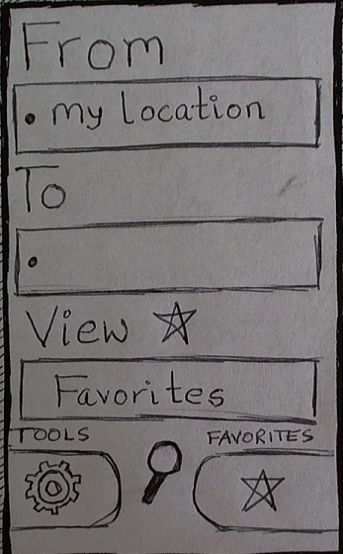
Figure 1 - Main Screen v1.0
In this paper, we will only include the main screen evolution, since it was the main and most essential item of our application. The rest of the screens are discarded from current application, since we no longer use them.

Main Screen v1.0
The first version of the main screen included the items as shown in the Figure-1. The main idea was creating possible routes from one specified location to another given location.
The main screen also included “Favorites” feature, which can be added as favorites to the list for future list.
After conducting paper-prototype tests on younger users, who are more familiar to smart phones and computing systems than the older adults, the results showed that the labels and buttons were ambiguous, especially the magnifier symbol, repetition of Favorites labels and buttons in the screen and text boxes, therefore confusing. That led us to Main Screen v2.0

Main Screen v2.0
The second version was introduced as v1.0 caused confusions. We updated the main screen to v2.0 as shown in Figure 2.
In this version, we combined the magnifier glass with a “GO!” label for clarity, removed the route functionality since it was concluded to be unnecessary, changed the label to less computer related and separated the “Tools” and
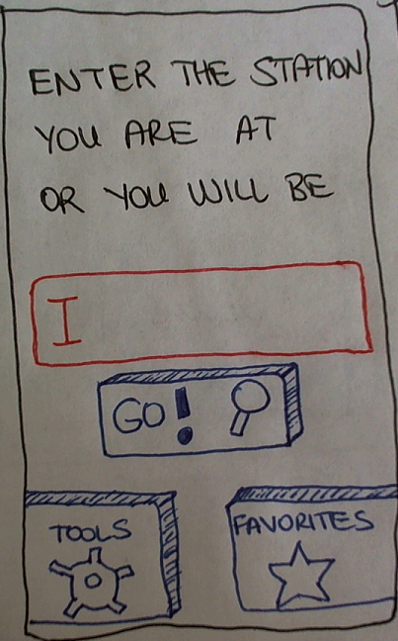
Figure 2 - Main Screen v2.0
“Favorites” buttons as we grouped them by using graphical design, which we learned in class by the invaluable comments of Jason Nawyn [7].
After updating to v2.0, we tested it on our first user group that totally changed the way of our design process.
The older adults seemed to be extremely confused about using the Tools and Favorites features of the application. That motivated us to run a survey on random users consist of 3 questions on Tools and Favorites features.
Surprisingly and on the contrary to what we thought, they unexceptionally thought that they were unnecessary. That’s when we really experienced one of the most important principles of HCI: “We were not our users!”
Following the rating of the comments on paper-prototype tests, it was proven that they are both not needed. As all users suggested, the sole purpose of the application is to provide simple information on MBTA vehicles. Therefore, we removed the “Favorites” and “Tools” functionality from the prototype, which led us to Main Screen v3.0

Main Screen v3.0
As we proceeded to the third version of our main screen interface, we’ve already learned a lot and needed to change many aspects of our application.

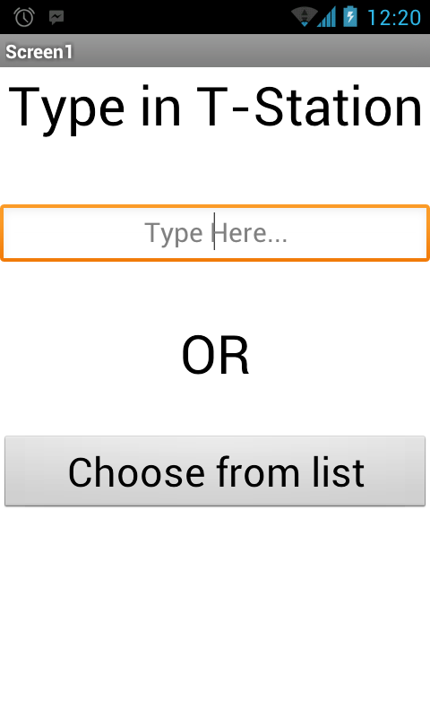
Figure 3 - Main Screen v3.0
After the paper prototype tests of v2.0, we simultaneously created a Lo-Fidelity (Lo-Fi) computer prototype of our application without functionality with regard to real-time date from MBTA servers.
With two similar lo-fi computer prototypes, we started to test the application on the first two user groups.
5 different individual tests for the User Group-2 and 4 different individual tests for User group-1 have been conducted.
The second user group came up with rather good results except small visual feedbacks. The vast majority of the User Group-1 on the other hand, provided important feedbacks on Main Screen v3.0 that suggested changing the user interface.
The feedbacks included:
- Difficulty in typing in using the default touch screen keyboard of Android OS,
- The lack of familiarity of keyboard usage,
- Difficulty in interacting with the phone’s touchscreen by means of pressing on buttons,
- Tendency to read the items on the screen by finger-following, which caused accidental press action command on the phone’s touchscreen.
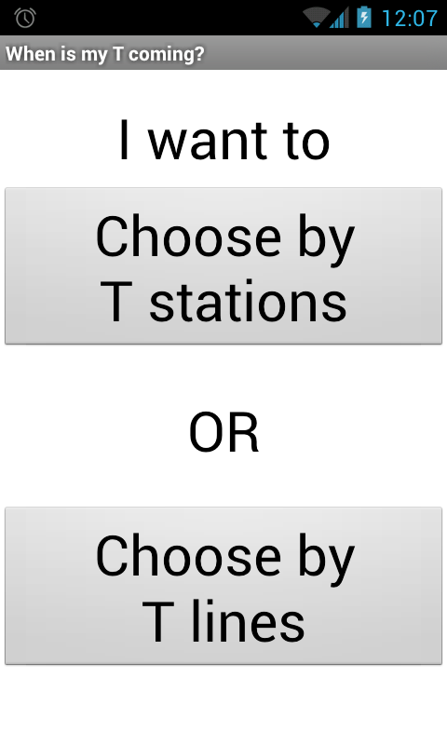
Figure 4 - Main Screen v4.0
During the heuristic evaluation week of our course, our fellow classmates Dana Lopes [8], Chen Chu [9] and Milesh Nima [10] also provided the similar feedbacks on the very same issues, with very small differentiations on details.
Because of the observed behavioral deficiencies and heuristic evaluation feedbacks from our classmates mentioned above, we decided to change the input style from type-in text box style to selection out of shown buttons style.
Eventually, as of the date of this report, the main screen is evolved to version 4.0 without any type-in inputs. The main screen as of this report included two buttons that allow users to select the station either by train station names or train line names as shown in Figure 4.

Main Screen v4.0
The most up-to-date version as of this report date is v4.0. On this version we present just two buttons as inputs for the user as it is shown in Figure 4.
Here, user either needs to select by T-Stations (Train Stations) or T-Lines (Train Lines).
Choosing by T-Stations retrieves the screen as shown in Figure 5 and retrieves the screen as shown in Figure 6 if chosen by T-Lines.
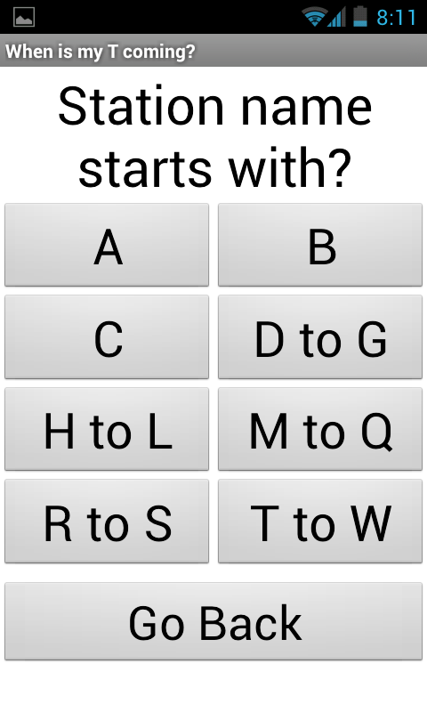
Figure 5 - Screen after choosing by T-Stations
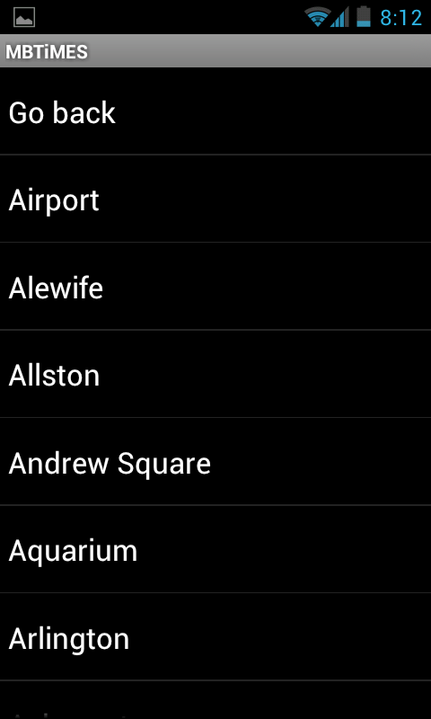
Figure 7 - Screen after choosing the initial letter
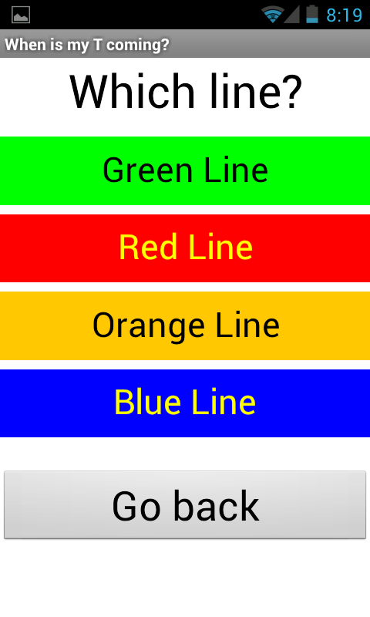
Figure 6 - Screen after choosing by T-Lines
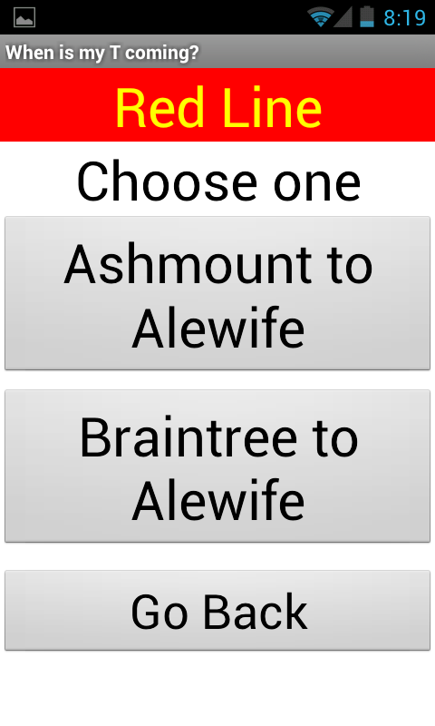
Figure 8 - Screen after choosing the T-Line
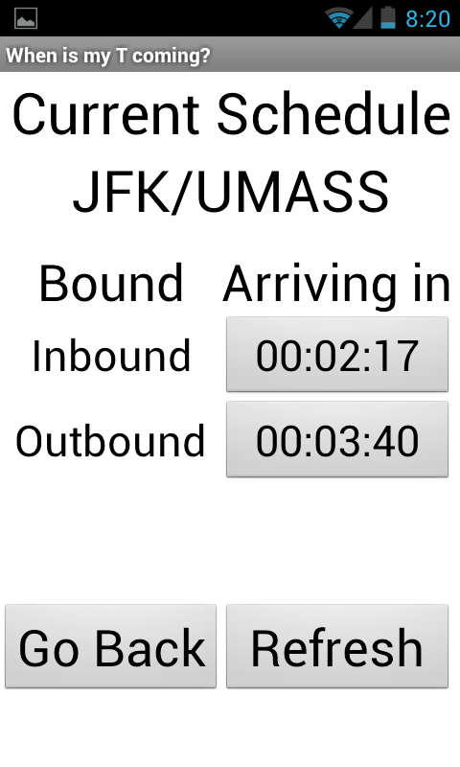
Figure 9 - Final (Result) Screen
After selecting by T-Stations, users need to press on the button that includes the first letter of the desired T-Station name. Since there were so many stations, rather than putting them in a huge list where users need to deal with the difficulty of scrolling down & up of a long list, we decided to split them by their initials without a need to use the
type-in style.
From the list on the screen shown in Figure 7, the user needs to select the station name that he/she wants to get the information of and after selecting the station name, final (result) screen is retrieves the information regarding on both directions (inbound-outbound) as shown in Figure 9.
If the user chooses to select the station names by T-Lines, after moving to T-Line selection screen as shown in Figure 6, user need to select the line, which takes him/her to the next screen as shown in Figure 8. After selecting the part of the line depending on the Line itself (either Green, Orange, Red or Blue), the user needs to select the desired station from the filtered list just like it’s done in Figure 7. And final screen comes up as in Figure 9, respectively.

IMPLEMENTATION

Main Components
- We use TinyDB [11] as the database management system to keep track of station names and their inbound and outbound codes to implement the application while parsing the data from MBTA feed.
- We have a web component that parses the MBTA feed.
- We have an exception handling protocol, which handles the application’s behavior when there is no or slow Internet connection.
- We access the database using a list structure.
- We have notifier and clock components that are used for reminder feature.
- The remaining time result for arrival is shown on buttons, where users get to set a reminder upon clicking on that button.

Design Decisions
- We use TinyDB as the database management system to keep track of station names and their inbound and outbound codes to implement the application while parsing the data from MBTA feed.
- We load the database only upon selecting the station name in order to preserve consistency.
- While listing the stations after choosing by
T-Stations, stations are sorted alphabetically. But, while listing the stations after choosing by T-Lines, stations are sorted by their order on the given line.
It is because, user’s interest while choosing by
T-Stations option is in a specific station, therefore it’s easier to locate a station when the list is sorted alphabetically.
While selecting the station name via choosing by
T-Lines on the other hand, user’s interest is in finding a station by its order, possibly because he/she couldn’t remember the name of the station, therefore it is easier to select the line on a recognition basis based on its order.
- To handle the green line estimation, we use MBTA’s schedule, based on the day of the week and the time of the day.

Implementation Problems
There is only one implementation problem so far.
During the fetching process of the data, the notifications are delayed and the application becomes unresponsive until the application’s slow Internet connection protocol handles the situation.

EVALUATION
During the early stages of our project decision, we conducted the ethnographic research and initial interviews with the members of Brookline Senior Center.
After deciding on the topic as our project, we selected the first group of users from our friends and conducted the paper prototype testing on them.
Beginning from Main Screen v1.0, we started to conduct our paper prototype testing on User Group 1 and User Group 2, mainly concentrating on the first user group.
The older adults, who attended to the tests, are selected randomly on public places like café’s, restaurants, parks etc. without regard to their age and race.
In total, 9 prototype tests were conducted from User Group 1 and 6 prototype tests were conducted from other user groups.
All users are briefed with the briefing included in our project website, and they performed every task that the current version included.

Critical Incidents
The major incidents from User Group 1 (older adults) mainly consist of:
- Lack of familiarity of using smart phones, touch screens and computing systems,
- Interacting difficulties with the touchscreens,
- Installation difficulties for the first time,
- Confusions about the labels with buttons,
- Difficulty in using the touchscreen keyboard,
- Reading the texts on screen by hand following, therefore accidental pressing on the touchscreen,
- Opinions of unnecessary usage of Tools and Favorites feature of the earlier versions of the application.
All the major and minor problematic areas regarding to the feedback from User Group 1 are fixed.
As for the User Group 2, the major incidents consist of:
- Confusion of labels and symbols on earlier versions of the application,
- Opinions of unnecessary usage of Tools and Favorites feature of the earlier versions of the application,
- Opinions of unnecessary usage of Route creation and evaluation of final screen.
As for the critiques from User Group 2, all major and minor issues are fixed.
The remaining issues mentioned below are never realized by any of the users, since the tests are conducted based on scenarios, rather than real-time usages.
Remaining issues that we are still working on and hoping to solve by the end of the submission deadline for the application are:
- Showing an estimation for Silver Line, which is not provided by MBTA feed,
- Making the application functional and usable depending on HCI principles for buses as well,
- Offering a type-in text box input style with auto-fill feature for advanced users,
- Designing the horizontal view of each screen for the application,

REFLECTION

Lessons Learned
The Main issues we failed to realize in the beginning of the course, which we came to realize as we proceeded with end of the class, are:
- “We are not our users!”
- “Just because we CAN do it, doesn’t mean that we SHOULD do it.”
- “Not holding onto the first idea we had and being able to let it go as users suggest otherwise.”
- “The 85% of the deficiencies in a user interface can be spotted within the first 3 user tests.”
- The importance of paper prototyping and the amount of time it saves.
- The importance of variable user subject selection from different user groups.
- Being consistent with the graphical design,
- Avoiding instructions unless it is crucial,
- The undeniable importance of simplicity on applications & the tendency of users towards it.
- The importance of selection of words for labels and buttons.

In The Future
If we did this project again we would:
- Do more ethnographic research, as it reveals so many issues just by interviewing and observing the users.
- Extensively evaluate the feasibility of programming phase of the project after deciding on the topic.
- Add the functionalities and components iteratively as we proceed with the user tests, instead of adding them at once.
- Start iterating from absolute simplicity. The more items that we include in our application, which we “think” is essential, turns out to be absolute “extra”.
- Do the user tests with multiple interface designs made by each team member independently.
- Do brainstorming on every problem all together, instead of working on it individually.
- Also do more user tests with multiple users on one test at the same time, in order to learn from what they converse between each other.
- Start testing the working High-Fidelity prototype earlier, since it can host multiple issues which we couldn’t have foreseen at the early stages of the implementation.
- Do on-field beta tests and evaluation on feedbacks depending on real-time users on real-time usages.

ACKNOWLEDGMENTS
We thank Prof. Stephen Intille for his invaluable comments, motivation and understanding on our demands, his parents for their help and patience, Zeeshan Sayyed [12] for his comments, tolerance and help throughout the course, Jason Nawyn for his generosity of sharing his experience, patience and comments on our projects, Brookline Senior Center staff and members for their efforts, enthusiasm and attendance and our fellow classmates Dana Lopes, Chen Chu and Milesh Nima for their valuable heuristic evaluations.

REFERENCES
- Android.
http://www.android.com
- MBTA Feed.
http://www.eot.state.ma.us/developers/realtime/
- MBTA Temporary Project Website.
http://www.ccs.neu.edu/home/n89nanda/nandakishorebhat/Project_web_page.html
- “.apk” format.
http://developer.android.com/guide/appendix/glossary.html
- Stephen Intille, Associate Professor.
http://www.ccs.neu.edu/faculty/intille.html
- Brookline Senior Center.
http://brooklineseniorcenter.org
- Jason Nawyn.
nawyn@media.mit.edu
- Dana Lopes.
lopes.d@husky.neu.edu
- Chen Chu.
chu.che@husky.neu.edu
- Milesh Nima.
nima.m@husky.neu.edu
- TinyDB.
http://tinydb.org
- Zeeshan Sayyed
Sayyed.z@husky.neu.edu

