February 18, 2004

CSU670 Project Description
Textual Visualization Plug-in for Eclipse
Karl Lieberherr and Jun Gong
Version 1.3

Introduction
- For this project, you are asked to implement an Eclipse plug-in, which textually highlights the classes selected in a class dictionary according to the input of your selector Language editor. Your final work may look like the picture showed below: (Figure 1)
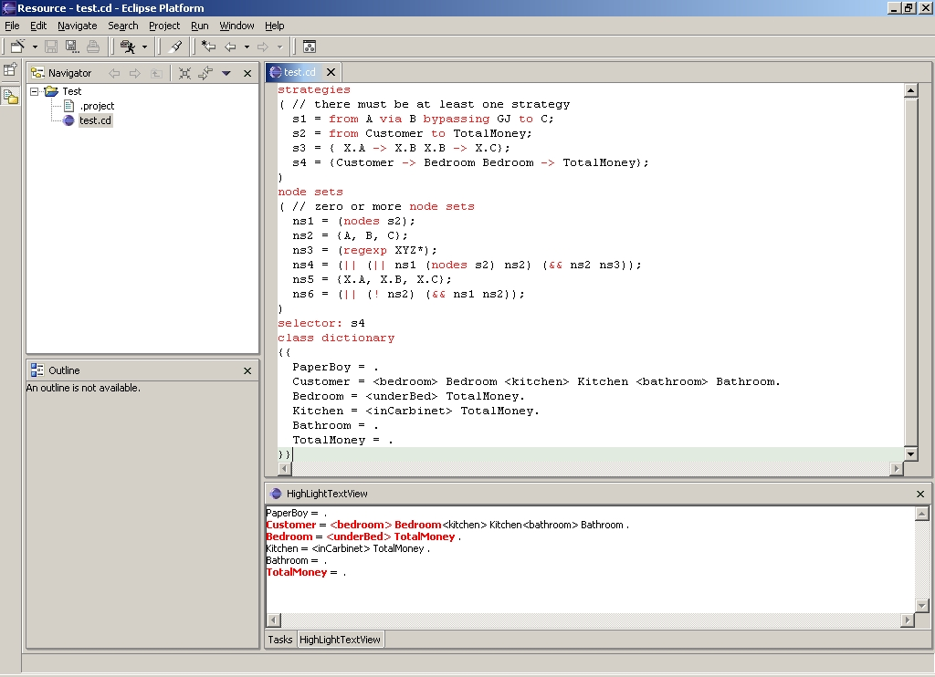

Figure 1: Selector Language Editor
- You should build your own plug-in from scratch based on the knowledge of DJ and Eclipse plug-in development, which you will learn from the materials provided.
- This document contains the description of the project, the development enviroment, the background knowledge you need to know, and the resources available.

Environment Setup
- To complete the above work, you need to download and install the Eclipse IDE, DJ plug-in for Eclipse, and DemeterJ:
- Eclipse 2.1.2
For writing the program, testing the plug-in, and almost everything else.
http://www.eclipse.org/downloads/index.php
- Extended DJ plug-in for Eclipse
For class graph traversal and highlighting.
An extended version of DJ Eclipse plug-in will be provided after you begin the second phase of the project.
You will use the AP Library that is a part of the DJ package. Enclosed is a program fragment that shows how to use the AP Library API. aplib.sg and aplib.cd don’t have Java documentation (javadoc). However, it is on the web:
http://www.ccs.neu.edu/research/demeter/AP-Library/

import edu.neu.ccs.demeter.aplib.Traversal;
import edu.neu.ccs.demeter.aplib.Traversal.EdgeSet;
import edu.neu.ccs.demeter.aplib.EdgeI;
import edu.neu.ccs.demeter.aplib.cd.ClassGraph;
import edu.neu.ccs.demeter.aplib.sg.Strategy;
import java.util.Iterator;

class Subgraph {
public static void main(String[] args) throws Exception {

ClassGraph cg = ClassGraph.fromString(
"A = B. B = [X] C. X = B. C = .");
Strategy s = Strategy.fromString("from A via X to C");
Traversal t = Traversal.compute(s, cg);
ClassGraph newCG = new ClassGraph();
for (Iterator it = t.getEdgeSets().iterator(); it.hasNext(); )
newCG.addEdge(((EdgeSet) it.next()).getEdge());
System.out.println(newCG);
}
}

dro <11> % javac Subgraph.java && java Subgraph
A = <b> B.
B = <x> X <c> C.
X = <b> B.

- DemeterJ 0.8.6
For parsing the generalized traversal language. http://www.ccs.neu.edu/research/demeter/software/docs/install.html
You are encouraged to write your semantic checker in Java using the DJ library. You should not attempt to learn the DemeterJ programming language beyond what you used in the Operating System Simulation homework (open classes, using the DemeterJ generated visitors for printing etc.).
Eclipse 2.1.2 comes as a zip file. To install it, you simply extract it into a folder. DJ plug-in for Eclipse also comes as a zip file, and you only need to extract the package into “plug-in” subdirectory in the eclipse home directory.
- Import external Java archives
After the creation of a new project, right click the root folder of that project -> select properties in the popup menu -> select Java Build Path page -> press Add External JARs -> find the jar file you are planning to add and press OK. For plug-in development, adding an external Java package is a little more tricky, please refer to the FAQ section later.
- Import existing Eclipse project
Click File -> Import... -> Existing Project into Workspace -> Next -> Select correct directory -> Finish.
- Be sure to add DJ plug-in as the required plug-in for your project.
- An extended version DJ plug-in is provided to you, which is capable of parsing the generalized Selector Language. Details of the usage of this plug-in will be discussed later in Files and Classes section.

Plug-in Overview
- The final plugin you turn in should have the following functionalities:
- Provide a Selector Language Editor, which is simply an extension to the text editor but has the capability of highlighting the Selector Language Keywords. Keywords are those strings in your extended Selector Language class dictionary.
- Contribute a button to the tool bar as part of your Selector Language Editor. When it is pressed, parse the content of your Selector Language Editor by using the provided SelectorLanguage class in the extended DJ package. Save strategy information appropriately. Then check the input for any semantic incorrectness (e.g., are all used variables defined?).
- Construct the corresponding ClassGraph object from the class dictionary that the user gave as input.
- Traverse the class graph according to the strategy that the user has specified. In “strategies” and “node subsets” parts of selector language input, the user has specified several strategies and node subset expressions. And in “selector:” part, the user tells which one he/she actually wants to use.
- Reconstruct the class dictionary from the ClassGraph and Traversal objects, output the generalized class dictionary to a seperated eclipse view (a kind of important Eclipse component) and highlight the classes and parts selected during the traversal.
- If the selector the user specified is a strategy, your plug-in should highlight both the nodes and the edges (e.g., for class dictionary A = <b> B, you should highlight <b> B ), while if the selector the user specified is the name of a node subset expression, only highlight the nodes (e.g., for the same class dictionary, you only highlight B).

- What you need to do for the first step is writing a Selector Language class dictionary, which extends the DJ strategy class dictionary so that you may accept and parse the input, traversing the class dictionary accordingly and highlight the selected classes in the output. The whole process is shown below:

Figure 2: Class Diagram Editor
AP Library
User
Selector Language
Write Selector Language
class dictionary

Strategy and NodeSubset Language
Extended DJ Library

Class Graph
Syntax and Semantic Checking
Strategy
SelectorLanguage
Strategy name
Traverse
Node set name
DJ Traversal
Reconstruct and highlight Class Dictionary
Class Graph

Note that the AP Library will not be neded in all cases when a node set name is selected.

Eclipse Plug-in Development
- http://www.eclipse.org/pde/index.html is a good place to start learning about Eclipse PDE (Plugin Development Environment). The PDE project provides a number of views and editors that make it easier to build plug-ins for Eclipse. Using the PDE, you can create your plug-in manifest file (plugin.xml), specify your plug-in runtime and other required plug-ins, define extension points, including their specific markup, associated XML Schema files with the extension point markup so extensions can be validated, create extensions to other plug-in extension points, etc. The PDE makes integrating plug-ins easy and fun.
- SWT (The Standard Widget Toolkit) carries a set of components that PDE provides, with which you can easily construct your Eclipse graphical user interface. And JFace provides a registry mechanism on top of SWT for image and font resource management.
- After you’ve learned about all of the above tools, you should read the tutorial on how to write an Eclipse plugin, which you can find at Eclipse help menu -> help content.
- Also, the lab excercises are very precious resources. You can find them here: (http://www.ccs.neu.edu/home/lieber/courses/csu670/f03/materials/eclipse/). It contains piles of useful examples showing you how to build everything your plug-in may have.

Text CD -> ClassGraph -> Highlighted Text CD
- Create the corresponding classgraph from the class dictionary the user inputed. You can do this by simply parsing the text class dictionary input with edu.neu.ccs.demeter.aplib.cd.ClassGraph.
- You can easily traverse a class graph by creating a Traversal object of that class graph. After the Traversal is created, you may retrieve all the edges and nodes within that Traversal by simply calling the member methods getEdgeSets() and getNodeSets().
- Highlight those classes in your outcome by updating the style properties of corresponding text tokens.

Useful Classes
- During your development of the plug-in, you may find following classes very useful:
- org.eclipse.ui.editors.text.TextEditor
- org.eclipse.jface.text.IDocument
- org.eclipse.swt.custom.StyledText
- org.eclipse.jface.text.rules.RuleBasedScanner
- org.eclipse.jface.text.IDocument
- org.eclipse.jface.text.IDocumentPartitioner
- org.eclipse.jface.text.source.SourceViewerConfiguration
- org.eclipse.ui.plugin.AbstractUIPlugin
- org.eclipse.ui.views.properties.PropertySheetPage;
- Research these classes and become an expert in them before you start writing your code.
- The extended DJ plug-in (Please note: this package will only be available at the start of the second phase of your project):
- edu.neu.ccs.demeter.aplib.sg.SelectorLanguage
You can use this class to parse the input of the SelectorLanguage Editor, by calling SelectorLanguage.parse(String).
List getLists() method. By calling this method, you will have a list containing two hashtables, one of which is a map from any strategy’s name to its content, and the other one of the hashtables is a map from any NodeSubset Language’s name to its content.
String getCD() method. By calling this method, you will get a class dictionary in text form, which is the forth part of the SelectorLanguage.
String getSelector() method. By calling this method, you will get the name of the strategy or node subset expression that the user would like to use for next round of highlighting.

Testing
- Run your plug-in as a Run-time Workbench program.
- If there’s time, an automatic testing tool written in JUnit will be provided. Otherwise, you should test your project with sufficient test cases to ensure that it behaves correctly according to the program specifications.

Suggested Project Phases
- This section gives our suggested working phases for implementing the textual highlighting plug-in. Following these phases is not required but highly recommended.
- Phase 1, Define the class dictionary of the Selector language that selects nodes and edges in a class graph. You need to add the Node Selection Language definition to the current strategy class dictionary provided. See sample input at the end.
- Phase 2, read documents about PDE, SWT, JFace, DJ, and anything else you think may be helpful. Do lab exercise 1,2,6,7,8,18. Don’t start phase 3 until you are totally clear about what you are asked to do and how you will do it.
- Phase 3, Add your Selector Language editor to the plugin. You should use the extended DJ plug-in provided to parse the input instead of your own extended class dictionary. In other words, put your class dictionary for step 1 aside after you’ve turned it in.
- Phase 4, Implement the Selector Language semantic checker and the translation to a class graph object (using the AP Library). After the completion of this phase, you should be able to construct the class graph object of a given class dictionary, get the traversal according to the information you collected in the last step, find out the edge set and node set of a traversal, and translate the class graph and traversal back to text class dictionary.
- Phase 5, Create an Eclipse view showing highlighted class dictionary. With the knowledge you obtained from earlier phases, you should be able to complete this quite easily.
- Please attempt to finish the first 4 parts with 2 weeks left till the deadline. Don't forget to save some time for the write-up, as it may take longer than anticipated.
- After each phase, you should save the state of the project to some other directory. This allows you to roll back to the last phase if you happened to take the wrong approach in solving the next phase. Not only that, if your program does not compile and you need to submit it, then you can submit the previous saved phase of the project. This is usually a good practice for big projects.
- It is useful that notice that the project has a subproject that is independent of Eclipse: 1. Design and test class dictionary for Selector Language. 2. Write and test semantic checker for Selector Language. 3. Write and test translator for Selector Language. The output is shown as a ClassGraph-object:
- edu.neu.ccs.demeter.aplib.cd.ClassGraph. For a node set output, the class graph will not contain any edges. Once you are done with this non-GUI part, you add the Eclipse part.
- The Selector Language needs a growth plan. Start with strategies and then node sets defined by (nodes s) where s is a strategy. When you have done the entire project continue with more phases of the Selector Language.

Submission
- The whole project is intentionally broken down into three parts, so you are required to turn in each part separately to ensure your proper progress.
- Turn in your extended class dictionary by Feb. 26, 2004 (Thursday). Your work will be used to parse some nontrivial inputs, and will be graded based on the performance.
- Turn in your semantic checker and translator by March 15, 2004. Print the class graph that shows what has been selected. Do lab exercise 1,2,6,7,8,18 and turn in the statement: We have done Eclipse exercises 1,2,6,7,8,18.
- Turn in your plug-in which has a syntax sensitive Selector Language editor and semantic checker and translator by March 22, 2004. Since for this part, class graph highlighting is not available, you may show your work by printing the class graph.
- By March 29, 2004 please turn in your completed plug-in (partial Selector Language as described above).
- By April 5, turn in your completed plug-in covering the entire Selector Language.
- By April 12, turn in your project report. Details to follow.

FAQ
- How to import the extended DJ package into my PDE project?
For the PDE (plug-in development environment) projects, you must put the external package you want to import in your project directory. Right click the root of your project in the Package Explorer View and choose “Properties“ item in the pop-up menu.
Choose “Java Build Path” tab. Click “Add JARs...” button. Find the expected package in your project directory and click “OK”.
- How to get the content of my SelectorLanguage Editor?
When you create the document for that Editor, keep a reference to that document by any reasonable means. Then when you want to have the text inside the Editor, simply call the get() method on that document.

Anything else
- Some example inputs. You should come up with the Selector Language Class Dictionary by abstracting from these samples.
strategies
( // there must be at least one strategy
s1 = from A via B bypassing GJ to C;
s2 = from Customer to TotalMoney;
s3 = { A -> B B -> C};
s4 = { X.A -> X.B X.B -> X.C};
)
node sets
( // zero or more node sets
ns1 = (nodes s1);
ns2 = {A, B, C};
ns3 = (regexp XYZ*);
ns4 = (|| (|| ns1 (nodes s2) ns2) (&& ns2 ns3));
ns5 = {X.A, X.B, X.C};
ns6 = (|| (! ns2) (&& ns1 ns2));
)
selector: ns1
class dictionary // an object of class Text follows
{{
A = B C.
B = D | E common C.
C = .
D = .
E = .
}}

- Your extended class dictionary should starts with:
SelectorLanguage =
"strategies" StrategyLanguage
"node" "sets" NodeSubsetLanguage …
StrategyLanguage = NPList(StrategyDef).
NodeSubsetLanguage = PList(NodeSubsetSpec).
......

