Master of Science in Computer Science
College of Computer and Information Science

Course Syllabus

Course Number/Name: CS 5800 Algorithms (Master Level)
Term: Spring 2014, 15 week term, Flipped Classroom

Dates: January 7, 2014 – April 15, 2014
On Campus: Tuesdays/6pm to 8pm
Credits: 4 credits
Faculty: Karl Lieberherr, Professor, CCIS
Northeastern University, 308A WVH
Office Hours: Tuesdays/6pm to 8pm
E-mail: lieber@ccs.neu.edu
Course web sites: http://nuonline.neu.edu/ (lectures and grades)
https://piazza.com/class#spring2014/cs5800
(communication, questions, debates, etc.)
http://www.ccs.neu.edu/home/lieber/courses/algorithms/cs5800/sp14/course-description.html (other information: homeworks, slides, etc.)

Teaching Staff: Zhengxing Chen czxttkl@gmail.com

Required Textbook:
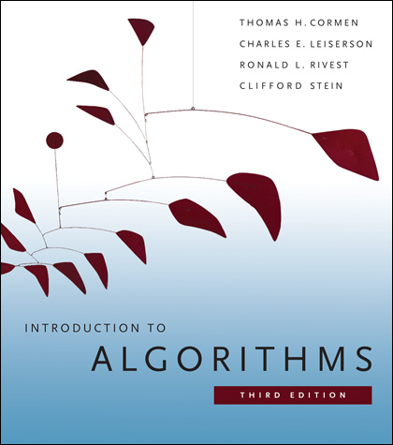

Introduction to Algorithms, 3rd Edition
Thomas Cormen, Charles Leiserson, Ronald Rivest and Clifford Stein
Published: July 2009, MIT Press
ISBN-10: 0262033844
Format: Hardcover

Optional Text:
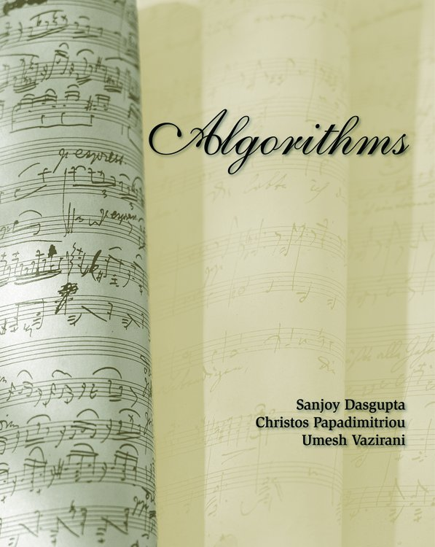

Algorithms
Sanjoy Dasgupta, Christos Papadimitriou, and Umesh Vazirani
Click here to access the online version of this book: Online Version of Algorithms

Course Prerequisites:

- Basic Programming
- Data Structures
- Discrete Math

Course Description:
Topics covered include Analysis of Algorithms, Divide and Conquer, Greedy, Dynamic Programming, Amortized Analysis, Graph Algorithms, Hashing, and other advanced topics.

Course Outcomes:

At the conclusion of this course the students will be able to:

- Identify the correct strategy (algorithm) for solving various problems, in particular typical problems likely to occur during software development.
- Write algorithms in pseudocode.
- Analyze algorithms for running time and required space.
- Know what algorithms are feasible and or scalable for a given concrete problem.
- Manipulate data structures.
- Be familiar with basic subroutines already packaged in most languages.

Course Rationale

Computer scientists, application developers, game programmers, business analysts, database administrators are faced daily with tasks that require a computer program. When such a program has to be written, it is necessary to formulate first a step-by-step description of the program, including the strategy independent of the programming language used, why it works, and how it relates to the input data in terms of efficiency. The choice of algorithms can make the difference between a fast, un-observable, routine and one that never finishes. The Algorithms course presents students with systematic ways to find strategies for most typical problems, but also with tools facilitating analysis of in terms of input data.

Course Methodology

Each week, you will be expected to:
- Review the week's learning objectives.
- Complete assigned readings.
- Review the lesson(s) in the weekly module.
- Participate in the discussion board (if necessary to ask/answer a question)
- Attend the on campus class meeting.
- Complete and submit assignment(s) by the due date.

Completing and Submitting Homework

Each week you may have required homework to complete and upload into Blackboard. Readings are required for each week as listed.

Please review the grading policy outlined in the course information page.

You must also write down with whom you worked on the assignment. If this changes from problem to problem, then you should write down this information separately with each problem.

Problem numbers are corresponding to the 3rd edition of Introduction to Algorithms. While the 2nd editions has similar problems with similar numbers, the actual exercises and their solutions are different, so make sure you are using the 3rd editions.

To complete a homework assignment you have two options:

- Write in longhand and convert to a digital format, preferably a PDF; This option is the least preferred because your handwriting might be difficult to read.
or
- Use one of several software programs available such as Latex and Wolfram Alfa and save file in PDF format.

To convert a longhand document into a digital format you can use the following options:

- Scan completed homework paper using a printer with a scan function.
- Capture an image of paper using a mobile or tablet device. There are numerous applications that use camera technology to capture the image of a document. Options include but are not limited to, TurboScan, Scanner Pro, DocScanner for iOS and Android and Document Scanner for Android.

Once you have completed the homework, select the respective Homework Assignment link and upload the completed digital file.

Important: Save filenames as Firstname.Lastname.HWM1M2.pdf
Example: Virgil.Pavlu.HWM1M2.pdf

Class Schedule / Topical Outline
Week | Dates | Topic | Readings/Assignments
1 | 1/7 – 1/14  1/7 - On Campus | Introduction to Algorithms | Reading Ch. 1, 2, 3, 4.1, 4.2  Homework M1 on algorithm debates
2 | 1/14 - 1/21  1/14 - On Campus | Recurrences | Reading Ch. 4.3, 4.5, (4.6 optional)  Homework M2
3 | 1/21 – 1/28  1/21 - On Campus | Searching and Sorting | Reading Ch. 2, Ch. 6, Ch. 8.1  Homework M3
4 | 1/28 – 2/4  1/28 - On Campus | Sorting and Median Stats | Reading Ch. 7 (7.3 optional), Ch 8.2, 8.3 (8.4 optional), Ch. 9  Homework M4
5 | 2/4 – 2/11  2/4 - On Campus | Greedy Algorithms | Reading Ch. 16 (16.3 optional) (16.4 and 16.5 not required)  Homework M5
6 | 2/11 – 2/18  2/11 - On Campus | Dynamic Programming Part 1 | Reading Ch. 15  Homework M6
7 | 2/18 – 2/25  2/18 - On Campus | Dynamic Programming Part 2 | Reading Ch. 15  Homework M7
8 | 2/25 – 3/4  2/25 - On Campus | Midterm Exam | Reading Ch. 10, Ch. 12  Midterm Exam
 | Spring Break
9 | 3/11– 3/18 | Binary Search Trees  Hashing and Red-Black Trees | Reading 11.1 – 11.3, (11.4 and 11.5 optional), Ch. 13 (13.4 optional)  Homework M8
10 | 3/18 – 3/25 | NP completeness | Ch. 34  Homework M9
11 | 3/25 – 4/1 | Graphs and Minimum Spanning Trees | Ch. 22, Ch. 23 (Ch. 21 optional)  Homework M10
12 | 4/1 – 4/8 | Shortest Paths | Ch. 24 (24.4 optional), Ch. 25 (25.3 optional)  Homework M11
13 | 4/8 – 4/15 | Network Flow | Ch. 26  Homework M12
14 | 4/15 – 4/22 | Linear Programming and NP Completeness | Ch. 29, 34  Homework M13
15 | 4/22 6-11 pm | Final Exam | Final Exam

Academic Honesty
- All work submitted for credit must be your own.
- You may discuss the homework problems or projects with your classmates, the teaching assistant(s), and instructor. You must acknowledge the people with whom you discussed your work, and you must write up your own solutions. Any written sources used (apart from the text) must also be acknowledged; however, you may not consult any solutions from previous years' assignments whether they are student or faculty generated.

Grading

Regular credit.
Every regular credit (non-extra credit) assignment is graded and given a number of points. In the end all points are summed up; this is P quantity in grade formula below. The sum of maximum number of points on regular credit is the quantity T in grade formula. Note that if T=P, even with no extra credit, you obtain the maximum grade.
Extra credit.
Make sure you understand how extra credit points contribute to your grade !
EXTRA CREDIT PROVIDE A LOWER BENEFIT THAN REGULAR CREDIT, so only work on EC after you finished the RC.
EXTRA CREDIT POLICY. There will be several projects/problems that students can work on for extra credit. They are clearly specified on assignments. For each one of those:
- If at least half of the points are obtained, score is going to be doubled. That is, if an extra-credit problem is worth 75 points and you get by normal grading 40 points, it will count as 80 extra credit points.
- If less than half of the points are obtained, the problem will be scored 0 (zero) extra credit points.
The sum of extra credit points is quantity E in grade formula below.
GRADE FORMULA.
Homework grade = (P+E) / (T+E)
EXAMS
There is a midterm and a final, both in class. The midterm and final each count 30% of your grade. The homeworks count 30% and 10% is for class participation, including your debates on Piazza.

